FACULTY EVALUATION
Programme Name: Resource Mobilization Programme
Session: Managing donor relations Donor reporting
Faculty Name: Beatrix Masime
No. of Respondents: 8
No. of Participants: 10
Evaluation Parameter | (%) Individual Score | (%) Programme Average
Punctuality | 100 | 96
Clarity of presentation | 100 | 94
Degree of preparation | 100 | 94
Course design & org | 94 | 91
Content & methodology | 97 | 93
Quality of discussions | 97 | 94
Relevance to work | 97 | 95
Average scores | 98 | 94

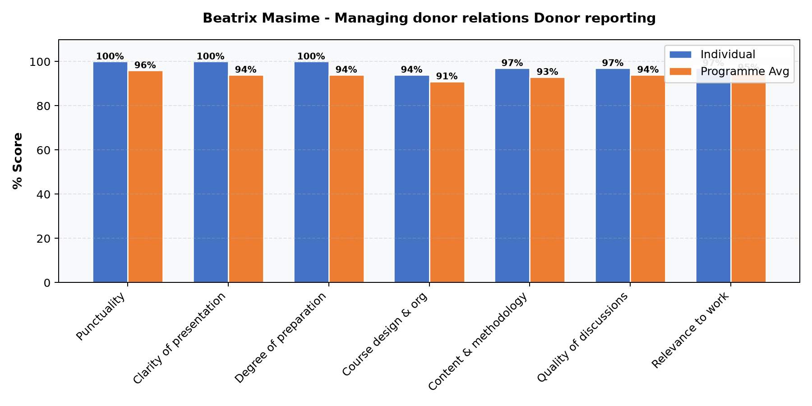

Comments & Feedback
- • Presentation was well thought out
SUBMITTED THROUGH:
NAME: ______________________ SIGN: ______________________ DATE: ______________________

